Open Ended LAB
Build a Convolutional Neural Network (CNN) using Python and TensorFlow/Keras to classify images of Cats and Dogs.
Code example:
!wget https://zenodo.org/records/5226945/files/cats_dogs_light.zip

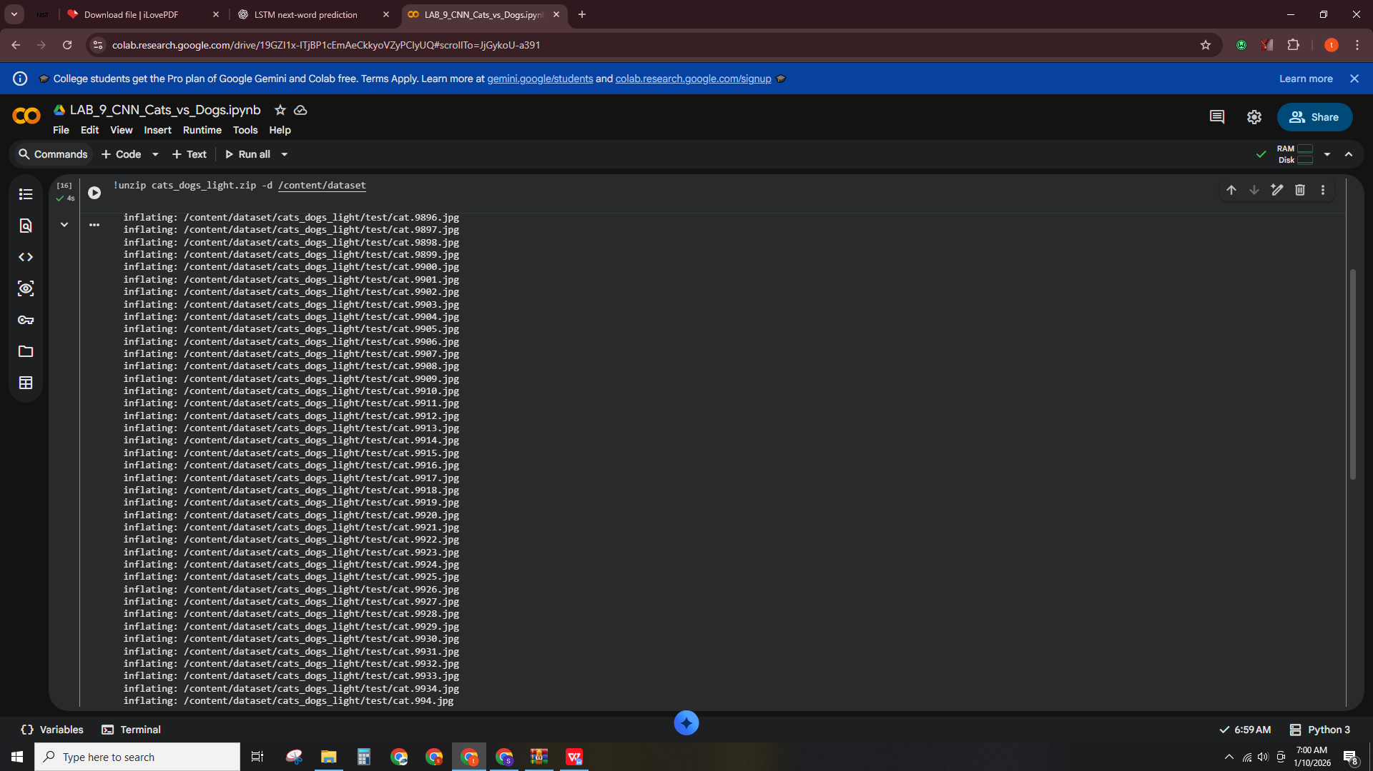
- Organize the dataset as:
dataset/
cats/
dogs/
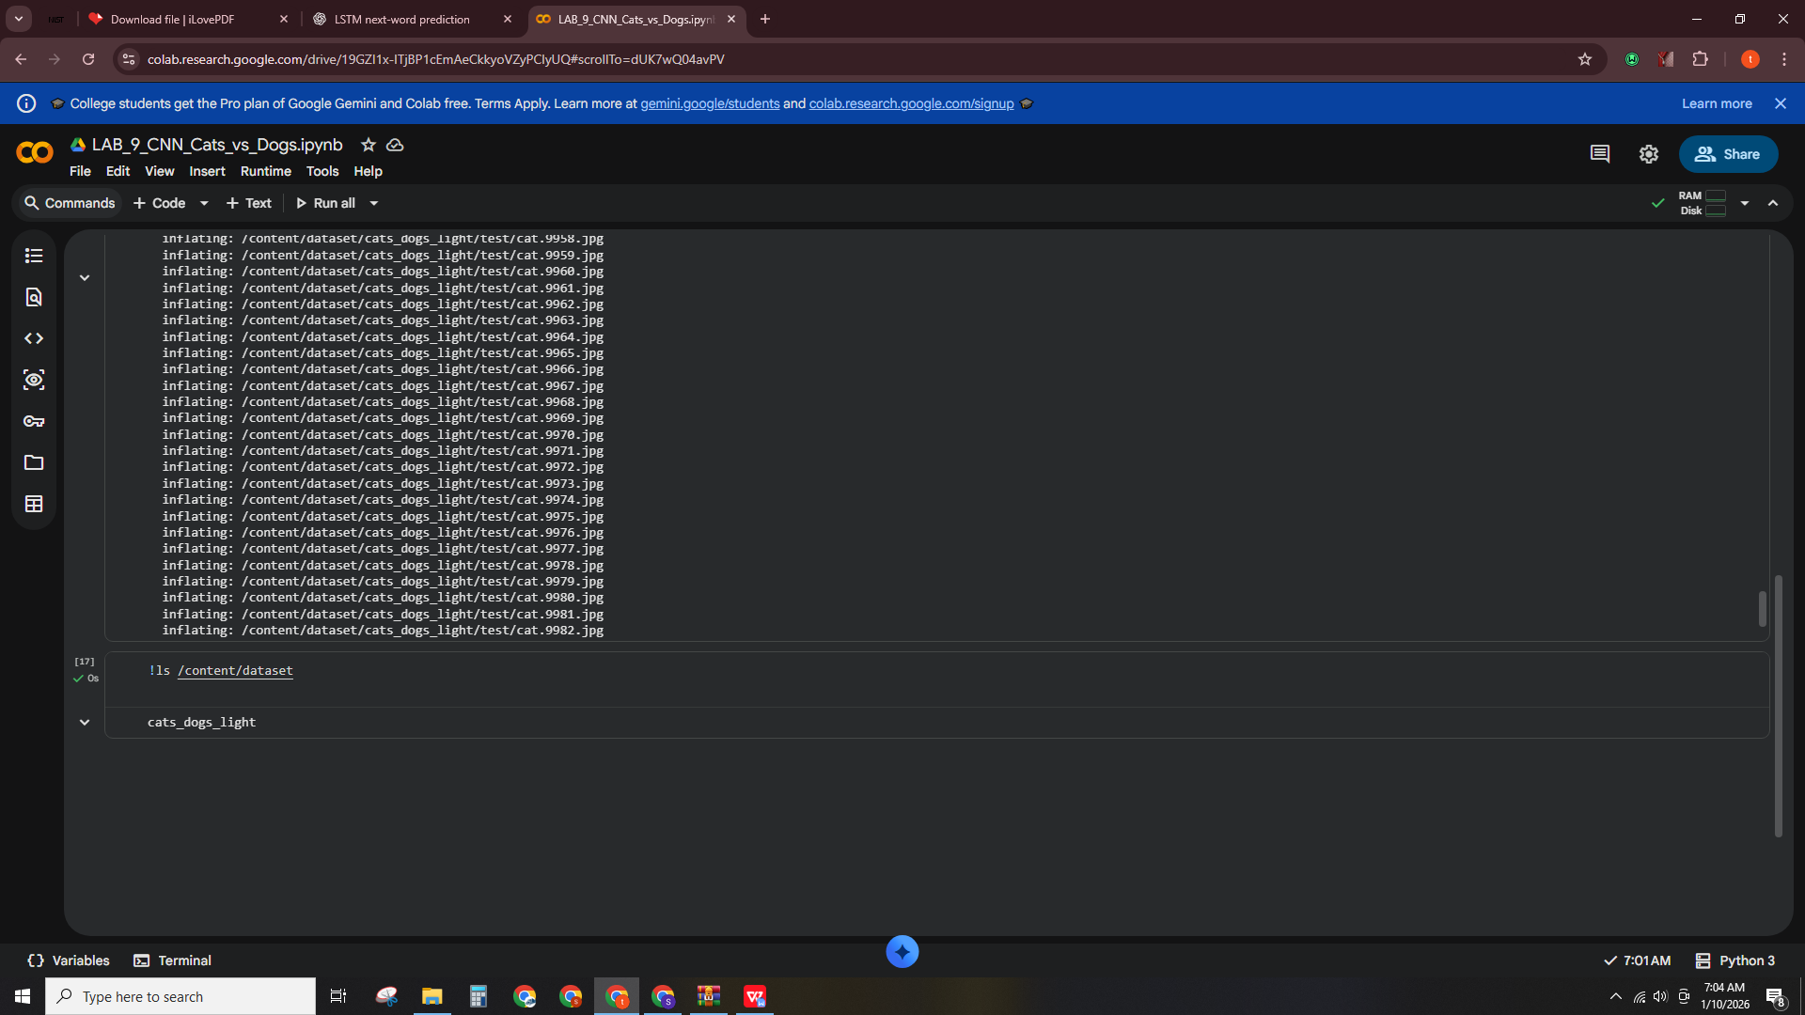
- Write Python code to:
- Load and preprocess images (resize to 150×150)
- Split into training (80%) and testing (20%)
- Build a CNN model
- Train the model for 10–20 epochs
- Plot training & validation accuracy and loss
- Evaluate model performance using a confusion matrix
- Predict whether a new input image is Cat or Dog
Code example:
from tensorflow.keras.models import Sequential
from tensorflow.keras.layers import Conv2D, MaxPooling2D, Flatten, Dense, Dropout

model = Sequential()
model.add(Conv2D(32, (3,3), activation='relu', input_shape=(150,150,3)))
model.add(MaxPooling2D(2,2))
model.add(Conv2D(64, (3,3), activation='relu'))
model.add(MaxPooling2D(2,2))
model.add(Conv2D(128, (3,3), activation='relu'))
model.add(MaxPooling2D(2,2))
model.add(Flatten())
model.add(Dense(128, activation='relu'))
model.add(Dropout(0.5))
model.add(Dense(1, activation='sigmoid'))
model.compile(
optimizer='adam',
loss='binary_crossentropy',
metrics=['accuracy']
)

model.summary()
Output:
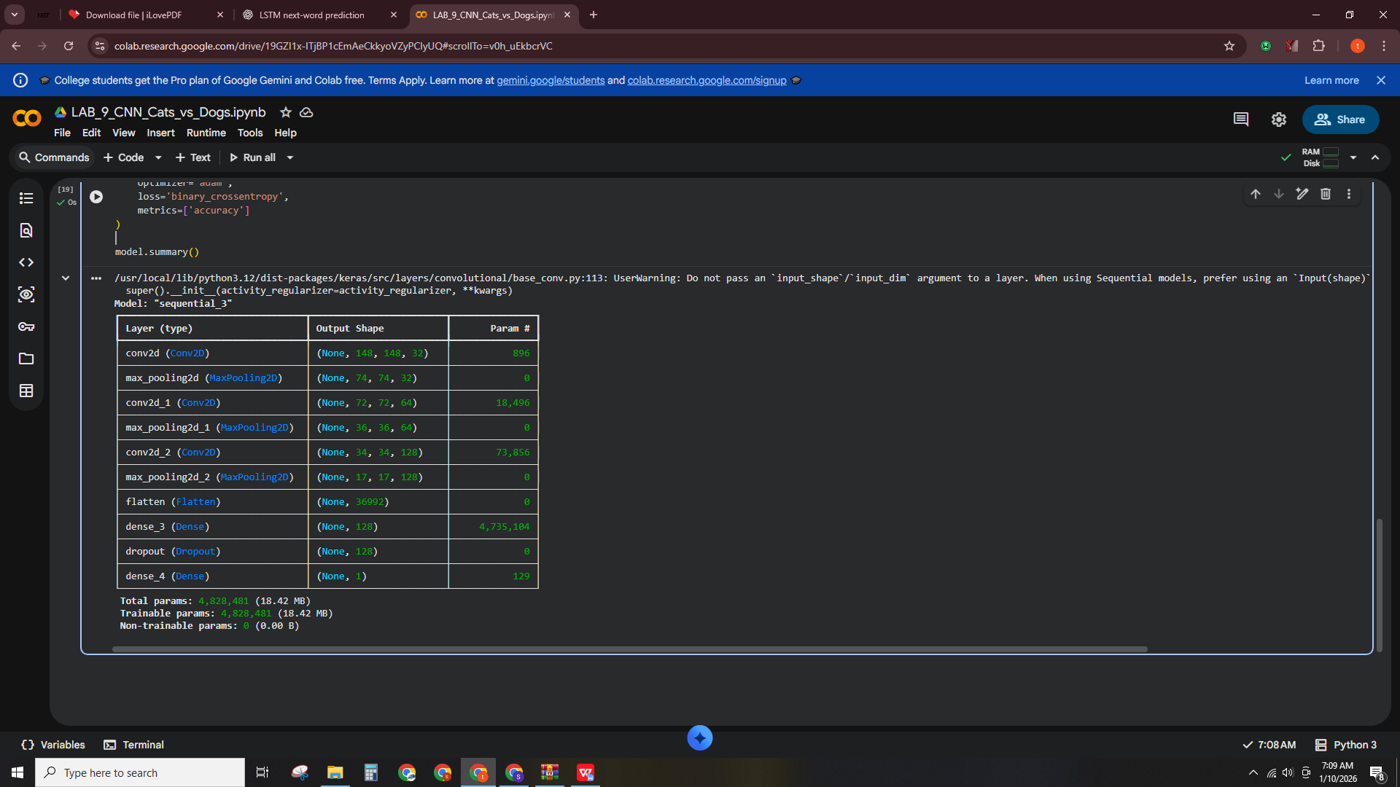
- At the end of the program, show the prediction result for a test image:
  - "This image is a CAT"
  - or
"This image is a DOG"
Code example:
from tensorflow.keras.preprocessing.image import ImageDataGenerator
# Image preprocessing
img_height = 150
img_width = 150
batch_size = 32

datagen = ImageDataGenerator(
rescale=1./255, # normalize pixel values
validation_split=0.2 # 80% train, 20% validation
)

# Training data generator
train_data = datagen.flow_from_directory(
'/content/dataset',
target_size=(img_height, img_width),
batch_size=batch_size,
class_mode='binary',
subset='training'
)

# Validation data generator
val_data = datagen.flow_from_directory(
'/content/dataset',
target_size=(img_height, img_width),
batch_size=batch_size,
class_mode='binary',
subset='validation'
)

Output:
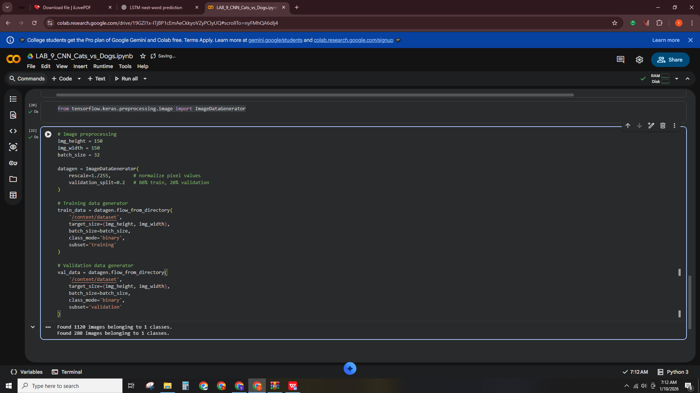
Code:
history = model.fit(
train_data,
epochs=15,
validation_data=val_data
)

Output:
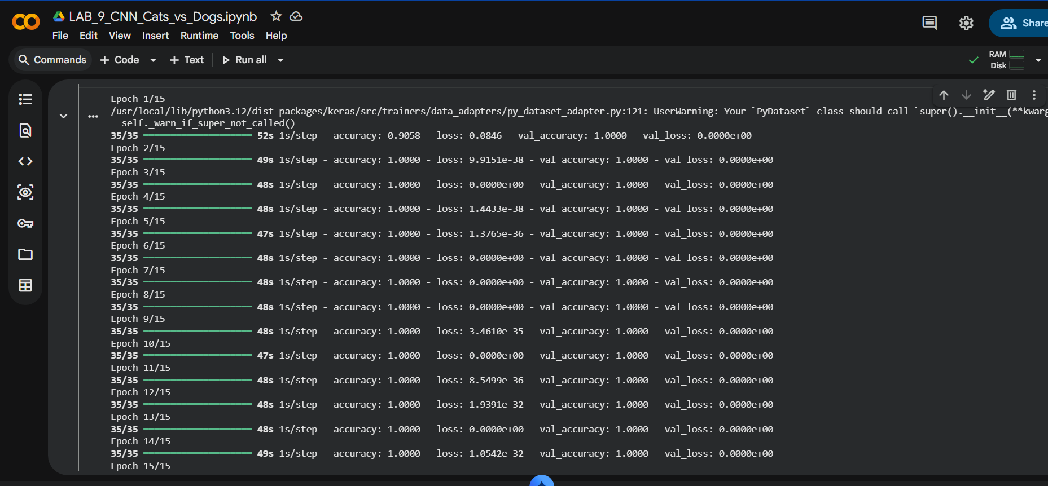
Code:
import matplotlib.pyplot as plt

# Accuracy
plt.plot(history.history['accuracy'], label='Train Accuracy')
plt.plot(history.history['val_accuracy'], label='Validation Accuracy')
plt.title('Training & Validation Accuracy')
plt.legend()
plt.show()

# Loss
plt.plot(history.history['loss'], label='Train Loss')
plt.plot(history.history['val_loss'], label='Validation Loss')
plt.title('Training & Validation Loss')
plt.legend()
plt.show()
Output:
